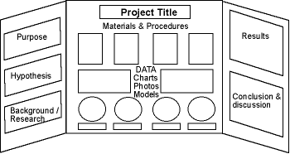

Link on where to get science project ideas from….
http://www.sciencebuddies.org/science-fair-projects/project_display_board.shtml

